LLM API Integration

API Request and Response

POST: S01 – Text to Audio
Request and Response
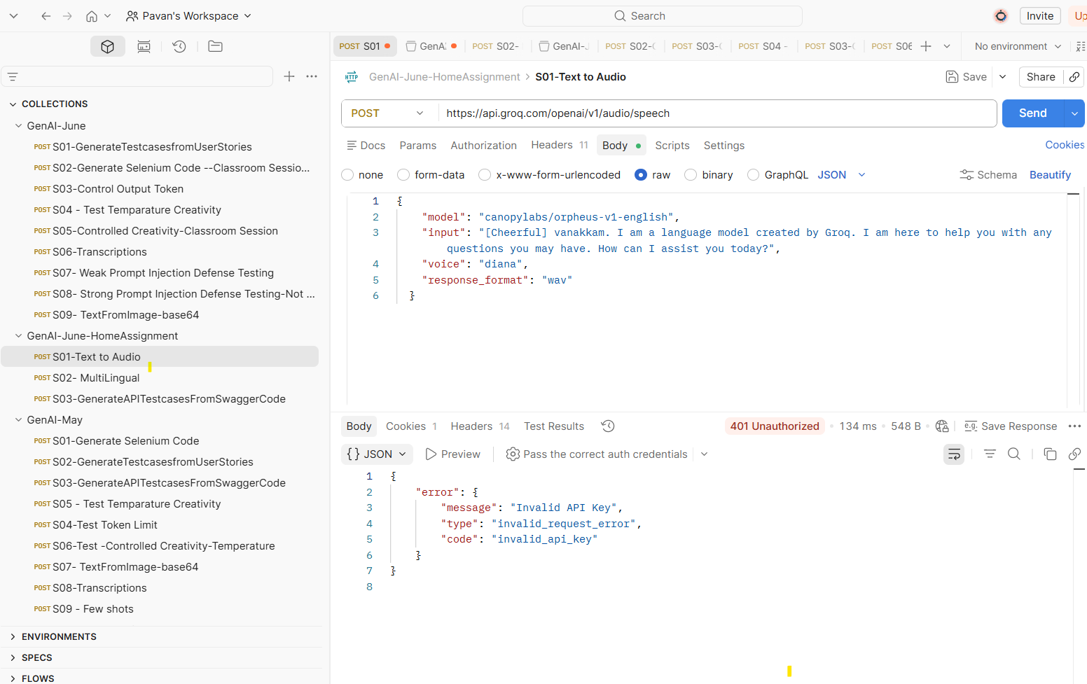

POST S02 – Multilingual
Request
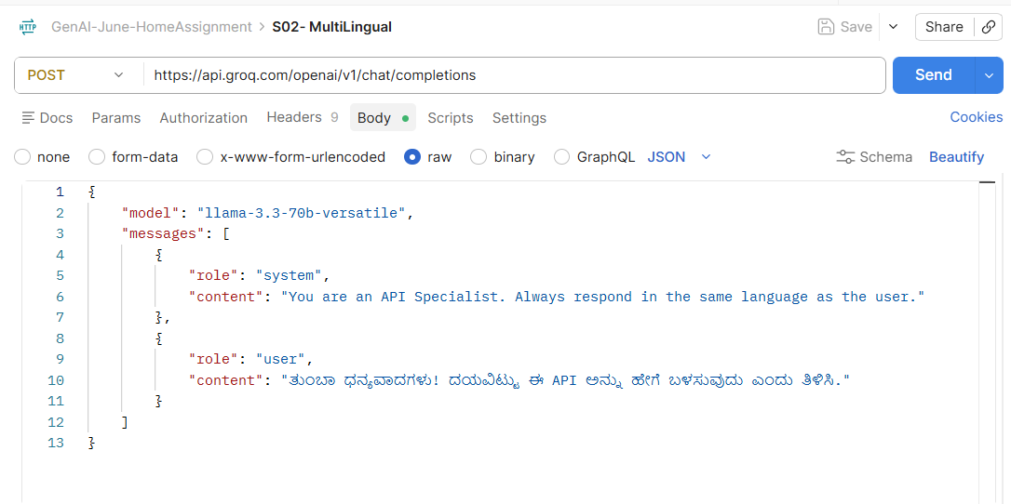

Response
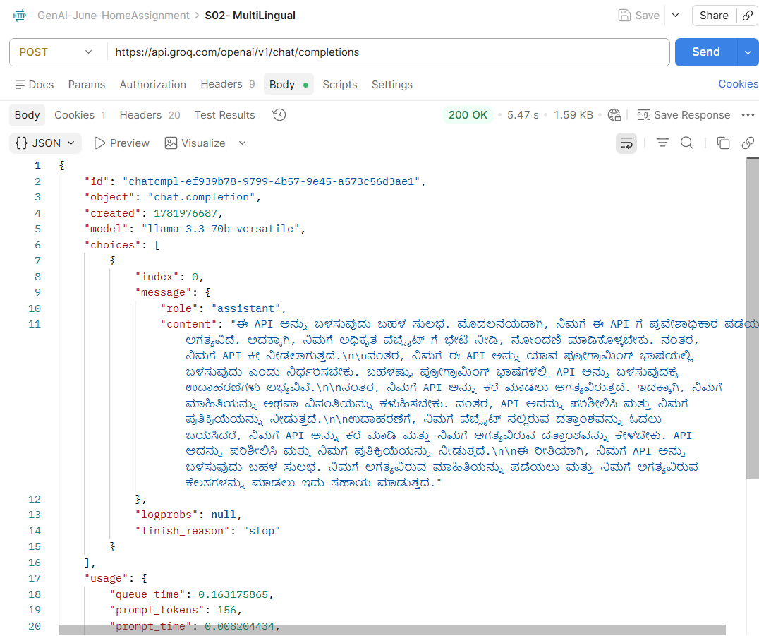
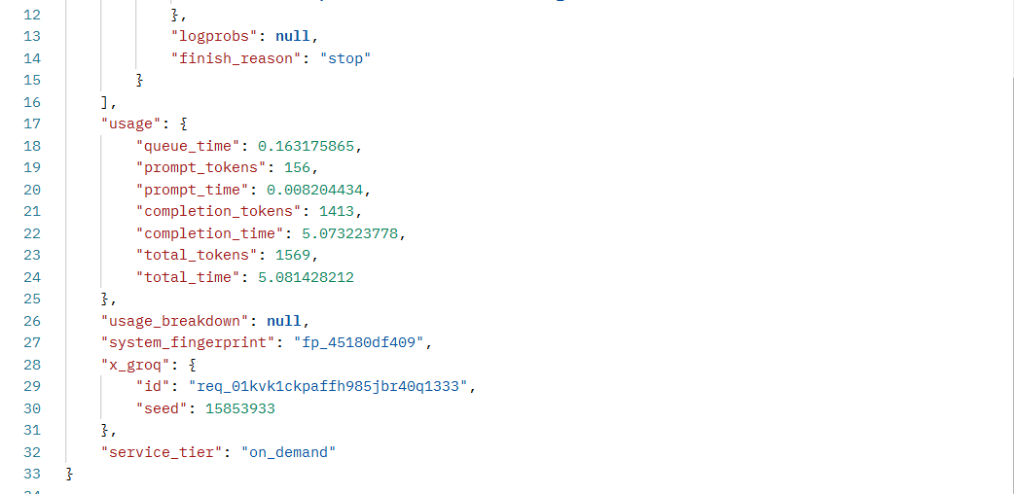

POST S03 – GenerateAPITestCasesFrom SwaggerCode

Request
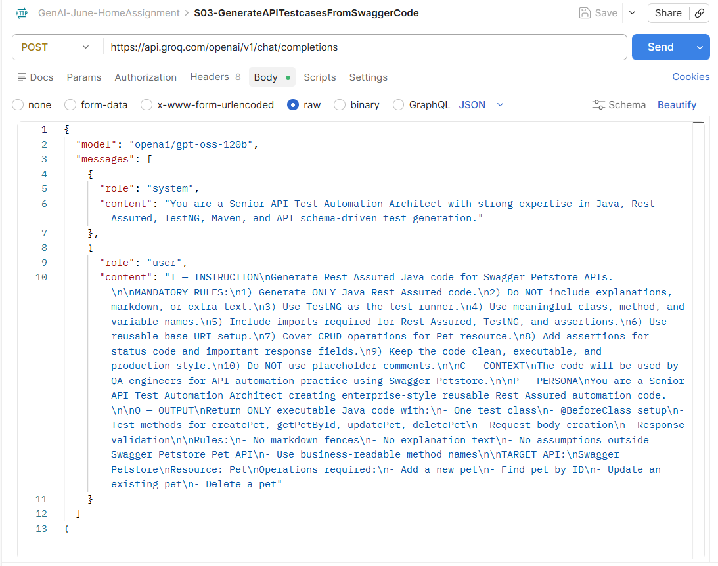

Response

{
"id": "chatcmpl-01d1b9d5-c5d4-45cf-a262-d0ddcbd1b6c4",
"object": "chat.completion",
"created": 1781934379,
"model": "openai/gpt-oss-120b",
"choices": [
{
"index": 0,
"message": {
"role": "assistant",
"content": "import io.restassured.RestAssured;\nimport io.restassured.http.ContentType;\nimport io.restassured.response.Response;\nimport org.testng.annotations.BeforeClass;\nimport org.testng.annotations.Test;\nimport java.util.HashMap;\nimport java.util.Map;\nimport java.util.Random;\nimport static org.hamcrest.Matchers.equalTo;\nimport static org.testng.Assert.assertEquals;\n\npublic class PetApiTests {\n\n private static long petId;\n private static final String PET_NAME = \"AutomationPet\";\n private static final String PET_STATUS = \"available\";\n\n @BeforeClass\n public void setUp() {\n RestAssured.baseURI = \"https://petstore.swagger.io/v2\";\n petId = new Random().nextLong() & Long.MAX_VALUE; // ensure positive\n }\n\n @Test(priority = 1)\n public void createPet() {\n Map<String, Object> pet = new HashMap<>();\n pet.put(\"id\", petId);\n pet.put(\"name\", PET_NAME);\n pet.put(\"status\", PET_STATUS);\n\n Response response = RestAssured.given()\n .contentType(ContentType.JSON)\n .body(pet)\n .when()\n .post(\"/pet\")\n .then()\n .statusCode(200)\n .body(\"id\", equalTo((int) petId))\n .body(\"name\", equalTo(PET_NAME))\n .body(\"status\", equalTo(PET_STATUS))\n .extract()\n .response();\n\n assertEquals(response.jsonPath().getLong(\"id\"), petId);\n }\n\n @Test(priority = 2, dependsOnMethods = \"createPet\")\n public void getPetById() {\n Response response = RestAssured.given()\n .pathParam(\"petId\", petId)\n .when()\n .get(\"/pet/{petId}\")\n .then()\n .statusCode(200)\n .body(\"id\", equalTo((int) petId))\n .body(\"name\", equalTo(PET_NAME))\n .body(\"status\", equalTo(PET_STATUS))\n .extract()\n .response();\n\n assertEquals(response.jsonPath().getLong(\"id\"), petId);\n }\n\n @Test(priority = 3, dependsOnMethods = \"getPetById\")\n public void updatePet() {\n String updatedStatus = \"sold\";\n Map<String, Object> petUpdate = new HashMap<>();\n petUpdate.put(\"id\", petId);\n petUpdate.put(\"name\", PET_NAME);\n petUpdate.put(\"status\", updatedStatus);\n\n Response response = RestAssured.given()\n .contentType(ContentType.JSON)\n .body(petUpdate)\n .when()\n .put(\"/pet\")\n .then()\n .statusCode(200)\n .body(\"id\", equalTo((int) petId))\n .body(\"status\", equalTo(updatedStatus))\n .extract()\n .response();\n\n assertEquals(response.jsonPath().getString(\"status\"), updatedStatus);\n }\n\n @Test(priority = 4, dependsOnMethods = \"updatePet\")\n public void deletePet() {\n RestAssured.given()\n .pathParam(\"petId\", petId)\n .when()\n .delete(\"/pet/{petId}\")\n .then()\n .statusCode(200);\n\n RestAssured.given()\n .pathParam(\"petId\", petId)\n .when()\n .get(\"/pet/{petId}\")\n .then()\n .statusCode(404);\n }\n}",
"reasoning": "We need to output only Java code, no markdown fences, no explanations. Must include imports, class, @BeforeClass for baseURI setup, test methods for createPet, getPetById, updatePet, deletePet. Use RestAssured, TestNG, assertions. Use reusable base URI.\n\nNeed to include request body creation (likely using JSONObject or HashMap). Use meaningful names.\n\nWe must not include placeholders like // TODO. Must have actual code.\n\nWe'll need to generate a pet ID, maybe random. Use java.util.Random or UUID.\n\nWe'll need to store pet ID across methods, maybe as static variable.\n\nTestNG order: could use dependsOnMethods.\n\nImplement createPet: POST /pet with JSON body.\n\nGetPetById: GET /pet/{petId}\n\nUpdatePet: PUT /pet with JSON body (maybe change status).\n\nDeletePet: DELETE /pet/{petId}\n\nAdd assertions: status code 200 (or 201 for create?), and response fields like id, name, status.\n\nSwagger Petstore base URI: https://petstore.swagger.io/v2\n\nWe'll use RestAssured.baseURI in @BeforeClass.\n\nAdd imports: io.restassured.RestAssured; io.restassured.http.ContentType; io.restassured.response.Response; org.testng.annotations.*; static org.hamcrest.Matchers.*; org.testng.Assert.\n\nImplement code.\n\nMake class: PetApiTests.\n\nMethods: createPetTest, getPetByIdTest, updatePetTest, deletePetTest.\n\nUse static long petId.\n\nCreate request body as a Map<String,Object> with id, name, status.\n\nAdd assertions using response.then().statusCode(200) and body(\"id\", equalTo(petId)) etc.\n\nOk.\n\nNow produce final answer."
},
"logprobs": null,
"finish_reason": "stop"
}
],
"usage": {
"queue_time": 0.363987388,
"prompt_tokens": 396,
"prompt_time": 0.040717472,
"completion_tokens": 1101,
"completion_time": 2.272302851,
"total_tokens": 1497,
"total_time": 2.313020323,
"completion_tokens_details": {
"reasoning_tokens": 358
}
},
"usage_breakdown": null,
"system_fingerprint": "fp_3af2d41834",
"x_groq": {
"id": "req_01kvhs1hx3ekhvf163rxj54cmj",
"seed": 1783987730
},
"service_tier": "on_demand"
}

